**Lab – 4: How to create a global admin in Microsoft Azure?**

**Objective:** The objective of this lab is –

* To create a global admin in Microsoft Azure.

A user with this role has access to all administrative features in Azure Active Directory, as well as services that federate to Azure Active Directory like - Exchange Online, SharePoint Online, and Skype for Business Online. Only global administrators can assign other administrator roles. There can be more than one global administrator at your company. Global admins can reset the password for any user and all other administrators. In this lab, I am going to explain how to create a global admin in your enterprise in Azure AD.

**Prerequisite:** EMS Enterprise Mobility + Security E5.

**Steps:**

1. Sign in to your Azure Portal, by using the link - https://portal.azure.com/. Enter your credentials and click Sign In.

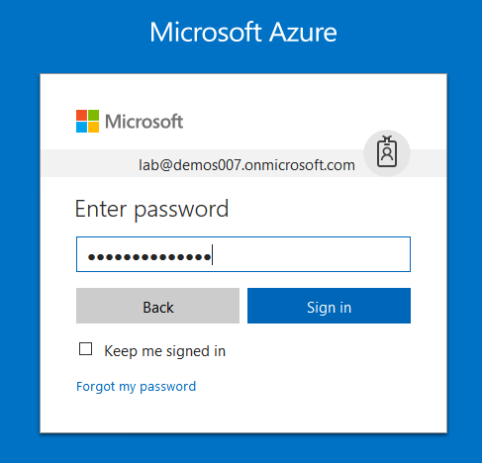

1. Microsoft Azure AD Dashboard will open.

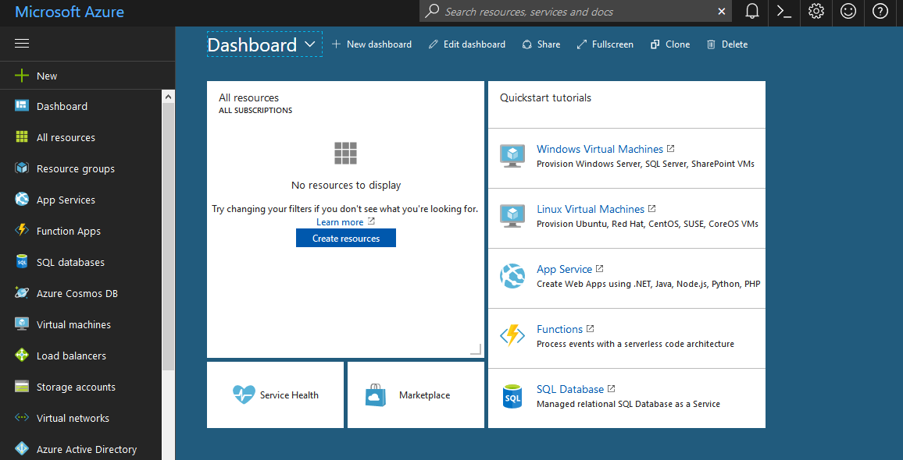

1. Now click **Azure Active Directory** from left-hand pane, and then select **Users and groups**.

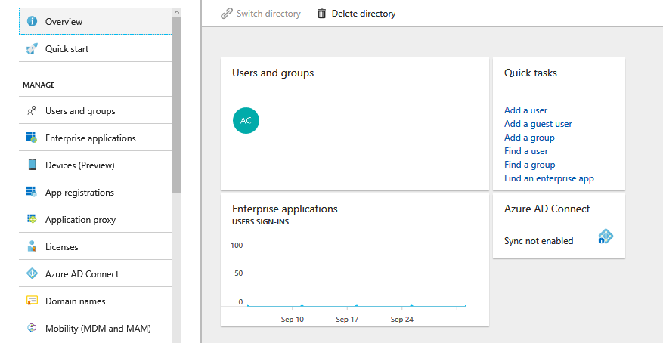

1. On **Users and groups**, select **All users**.

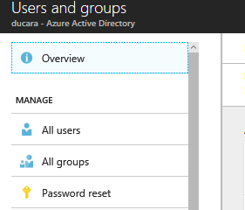

1. And, then select the **New user**, to add a user in Azure Portal.

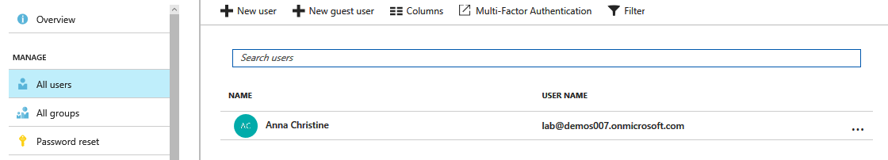

1. Enter details for the user, such as Name and User name. The domain name portion of the user name must either be the initial default domain name **"[domain name].onmicrosoft.com**" or a verified, non-federated custom domain name such as "contoso.com."

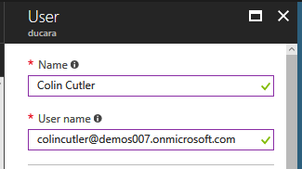

1. Then click **Profile**, to configure the General Profile settings. When you click Profile a Profile Page will open at the right-hand side, where you can fill information. Like – First Name, Last Name, Work Info details. Then click **OK**.

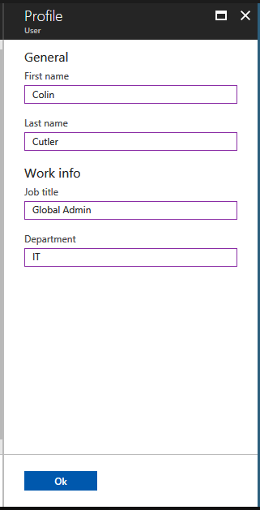

1. For creating a global admin, click **Directory role** and from the Directory Role page select **Global Administrator** and click **OK**.

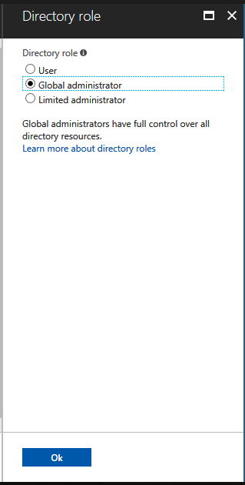

1. Now, the directory role will become Global Administrator.

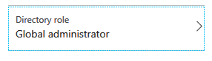

1. Then copy or otherwise note the generated global admin password so that you can provide it to the user after this process is complete.
2. Now on **User**, select **Create**.

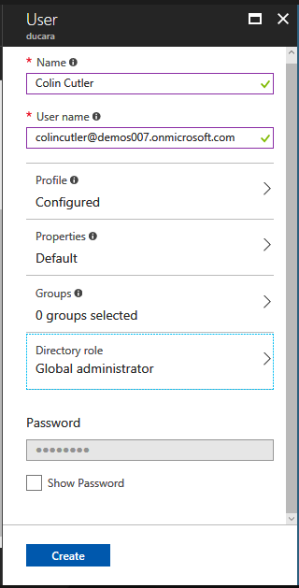

1. Now you can securely distribute the generated password to the new user so that the user can sign in as a global admin.
2. So, in this way you can create global administrators in Azure AD Portal.